
NATIONAL TEXTILE
UNIVERSITY
DEPARTMENT OF COMPUTER SCIENCE
SUBMITTED BY:
Fizza Shameen 23-NTU-CS-1157
SECTION SE: 5th(A)
Docker class Activity
SUBMITTED TO:
Sir Nasir Mehmood
SUBMISSION DATE:
12-19-2025

Docker class Activity:
- Make a html file:
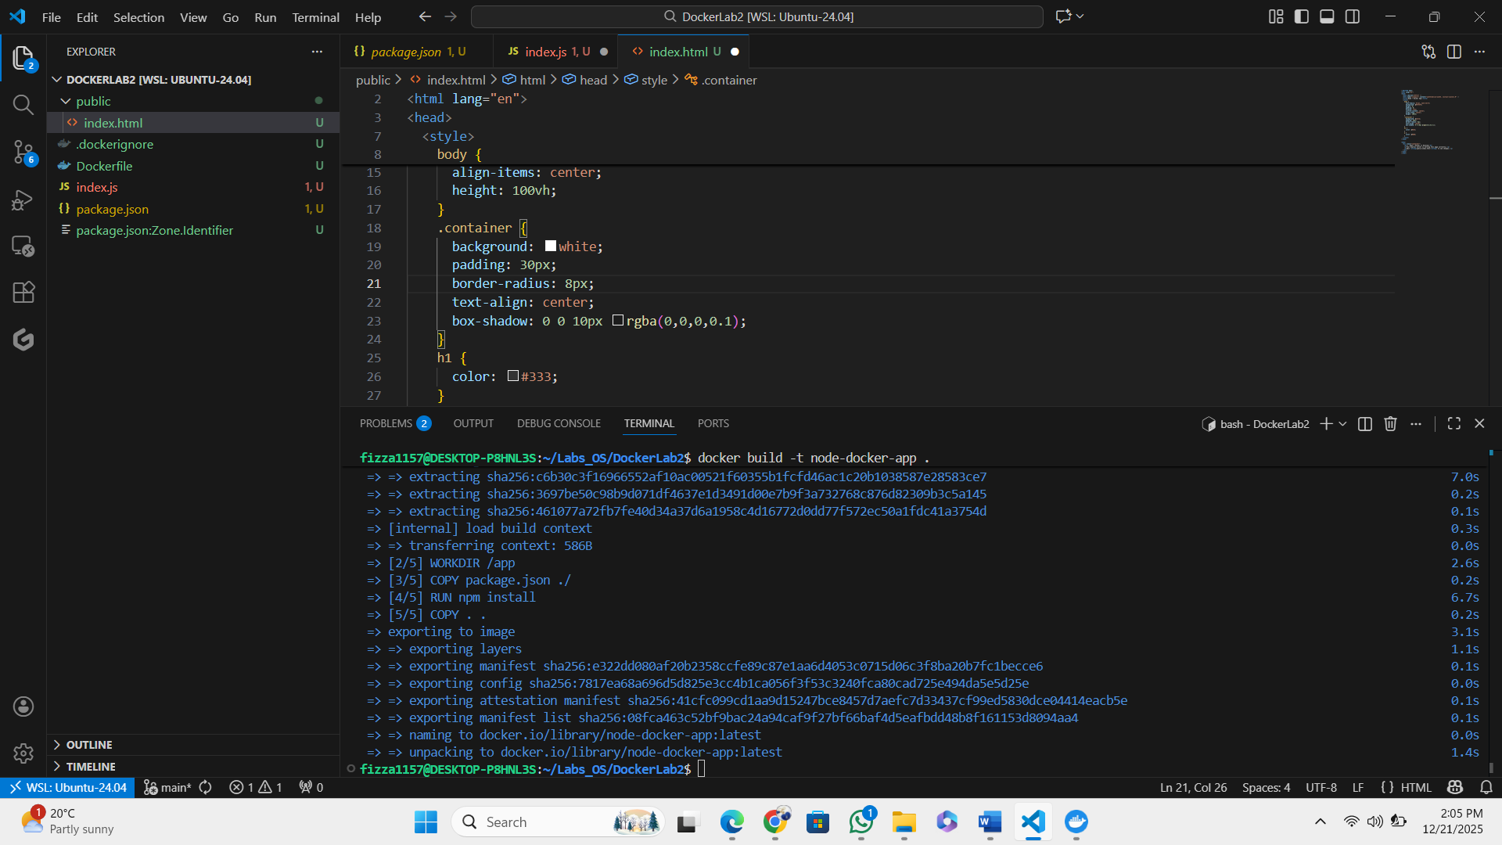

- Change index.js:
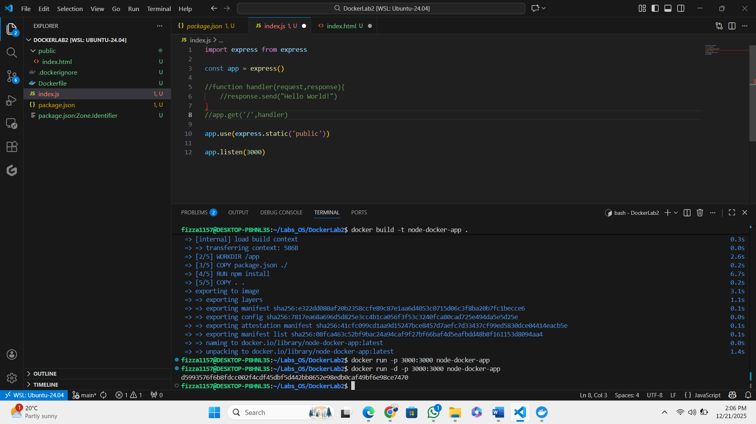

- Add this file path to Dockerfile:
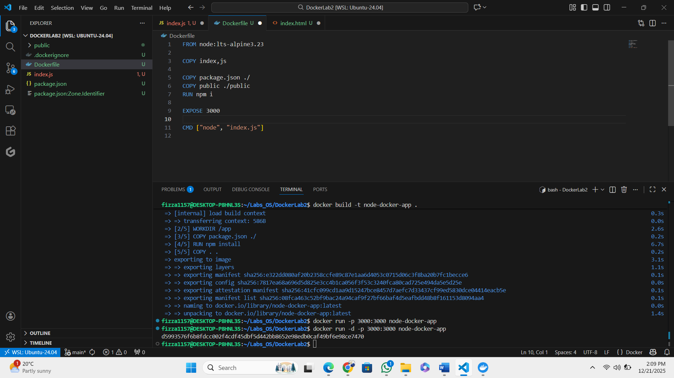

- Make a new image for this:
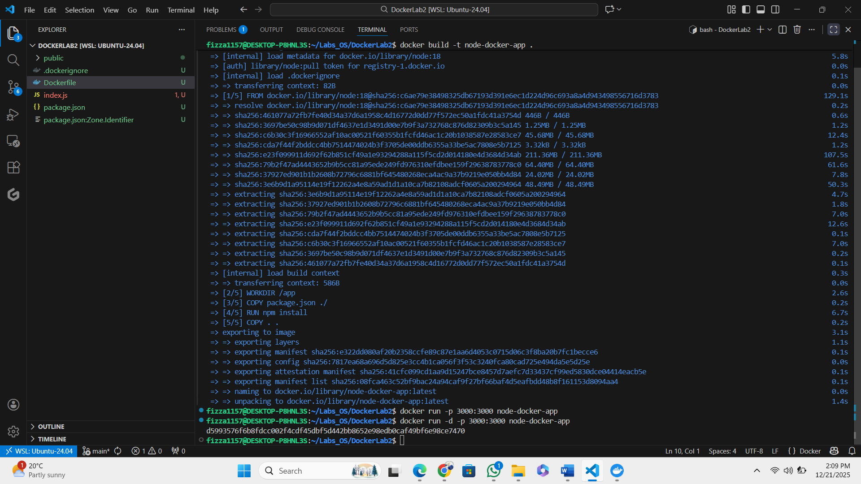

- Run this image:


